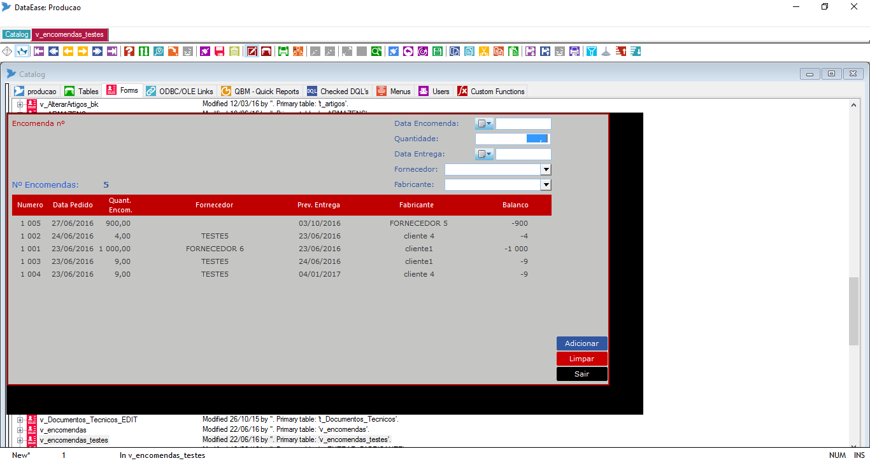

SubForm fields

Clicking here the value of this field should be filled here

Clicking here the value of this field should be filled here

The multiple choices are the same of those written into fields of subform