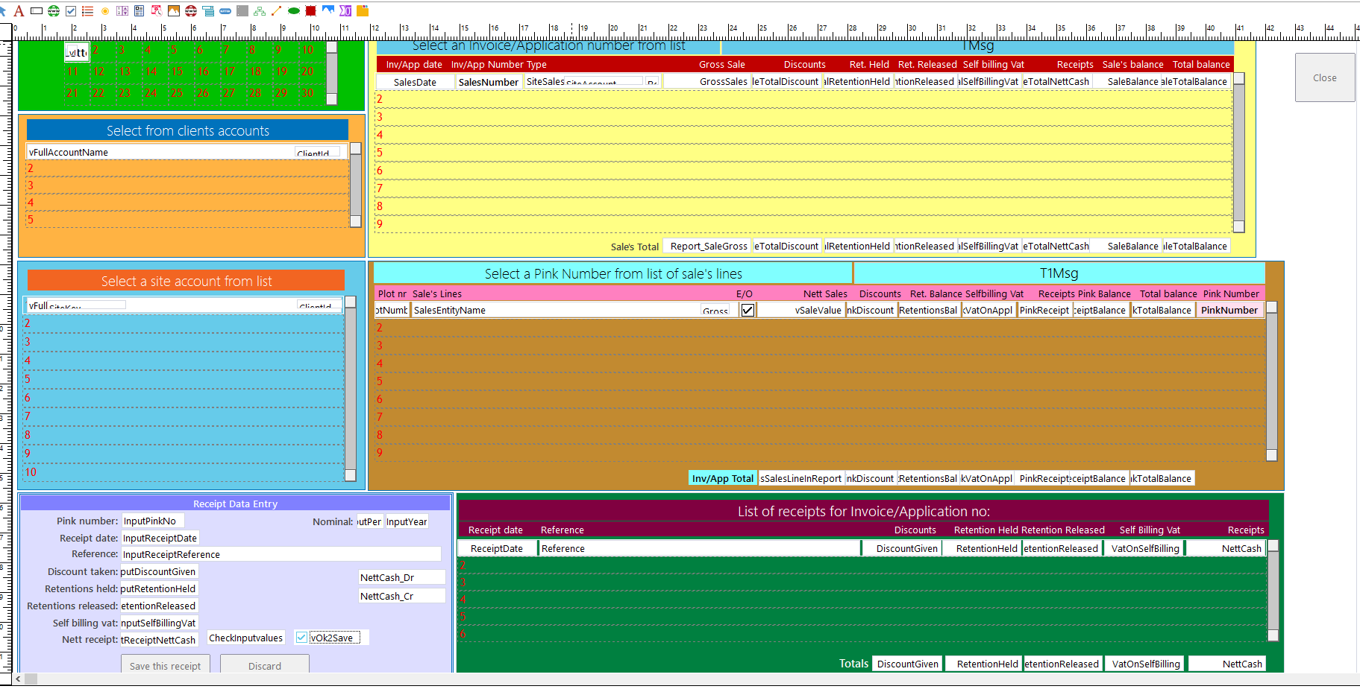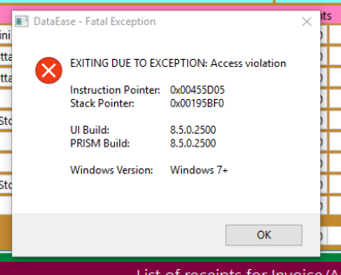
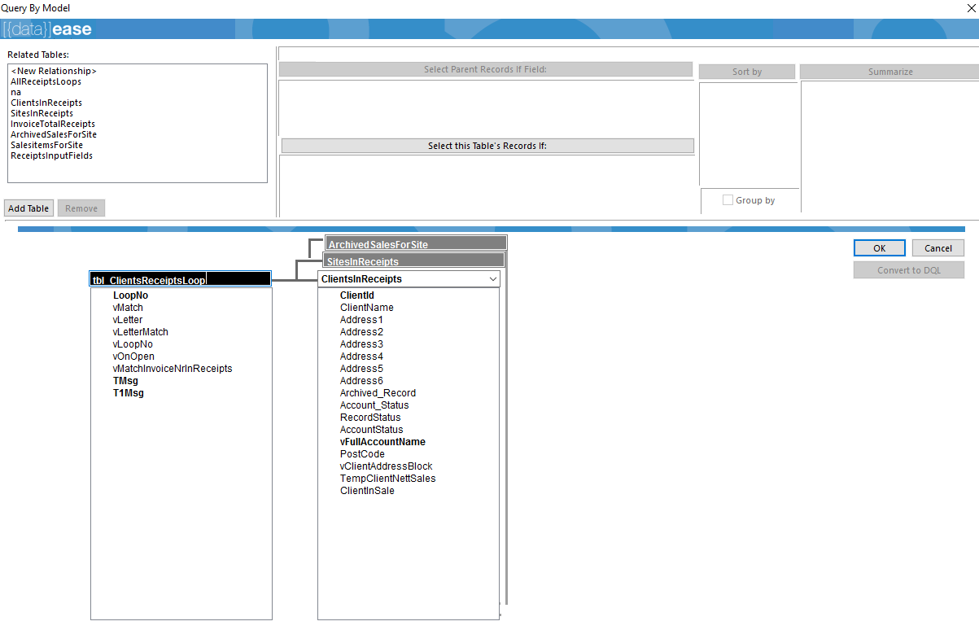
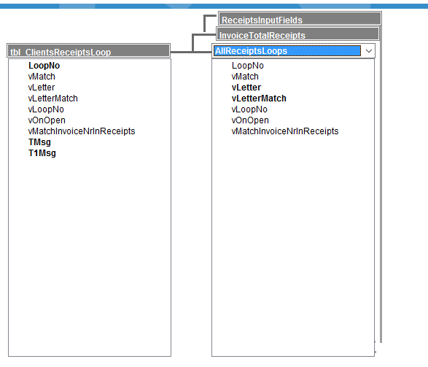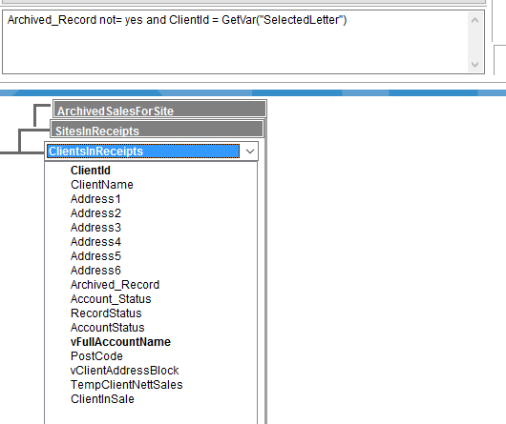
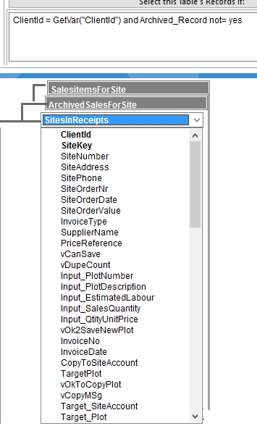
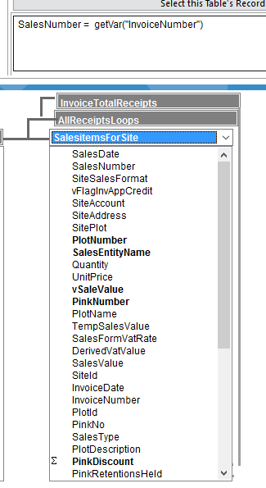
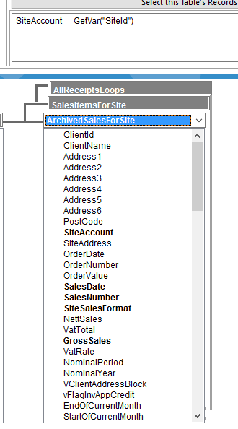
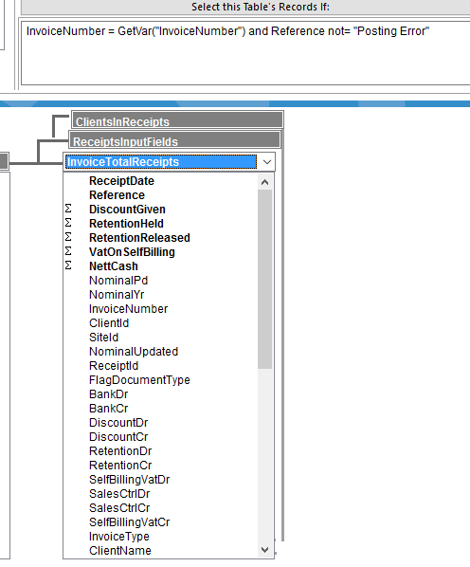
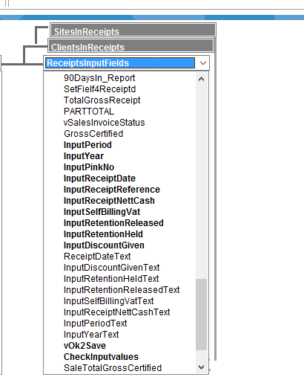

---Name: AllocateCashReceipt--------
---Dated: 16/09/2014-------------
---By: Sysop-----------------------
---Purpose: Allocate cash receipt from client----------
---Called by: SalesReceipts--------------------

define "t" number .
define "RcdNr" numeric string 8 .
define "tVatDebit" number .
define "tVatCredit" number .
define "InputVat" number .
tVatDebit := 0 .
tVatCredit := 0 .
InputVat := GetVar("InputSelfBillingVat") .

RcdNr := highest of tbl_ClientsReceipts ABS(ReceiptId) . ------GetUneek("Receipts.Bin",1) Bin no longer required.----
RcdNr := RcdNr + 1 .

--MESSAGE RcdNr WINDOW .
--MESSAGE ABS(RcdNr) WINDOW .

enter a record in tbl_ClientsReceipts

ReceiptDate := GetVar("InputReceiptDate") ;
Reference := upper(GetVar("InputReceiptReference")) ;
DiscountGiven := GetVar("InputDiscountGiven") ;
RetentionHeld := GetVar("InputRetentionHeld") ;
RetentionReleased := GetVar("InputRetentionReleased") ;
VatOnSelfBilling := GetVar("InputSelfBillingVat") ;
NettCash := GetVar("InputReceiptNettCash") ;
NominalPd := GetVar("NominalPeriod") ;
NominalYr := GetVar("NominalYeard") ;
InvoiceNumber := GetVar("InvoiceNumber") ;
InvoiceType := any tbl_Archived_Sales with(SalesNumber = GetVar("InvoiceNumber")) SiteSalesFormat ;
ClientId := GetVar("ClientId") ;
SiteId := GetVar("SiteId") ;
PinkNumber := GetVar("PinkNumber") ;
PlotNumber := any tbl_PlotSalesLines with(PinkNumber = GetVar("PinkNumber")) PlotNumber ;
PlotDescription := any tbl_PlotSalesLines with(PinkNumber = GetVar("PinkNumber")) SalesLineDescription ;
PlotId := any tbl_PlotSalesLines with(PinkNumber = GetVar("PinkNumber")) SITEPLOTID ;
ClientName := any tbl_Clients with(ClientId = GetVar("ClientId") ) ClientName ;
SiteAddress := midc(GetVar("SiteAddress"),11,length(GetVar("SiteAddress")-10) ) ;
ReceiptId := RcdNr .
------27.01.16---------------

modify records in tbl_Archived_SalesItems with(PinkNumber = GetVar("PinkNumber"))
PinkReceipt := PinkReceipt + GetVar("InputReceiptNettCash") ;
PinkDiscount := PinkDiscount + GetVar("InputDiscountGiven") ;
PinkRetentionsHeld := PinkRetentionsHeld + GetVar("InputRetentionHeld") ;
PinkRetentionsReleased := PinkRetentionsReleased + GetVar("InputRetentionReleased") ;
PinkVatOnAppl := PinkVatOnAppl + GetVar("InputSelfBillingVat") .

---------------------------------------------------------------

enter a record in tbl_BankEntry2Reconcile
TransactionNumber := GetVar("InvoiceNumber") ;
AccountNumber := GetVar("ClientId") ;
WhichLedger := "Receipts" ;
TransactionDate := GetVar("InputReceiptDate") ;
TransactionPeriod := GetVar("NominalPeriod") ;
TransactionYear := GetVar("NominalYear") ;
TransactionDescription := GetVar("InputReceiptReference") ;
Bank_Debit := GetVar("CashDR") ;
Bank_Credit := GetVar("CashCR") ;
FormLinkName := "B710" ;
PinkNumber := GetVar("PinkNumber") ;
RecordNo := RcdNr .
---------------------------------------------------------
if abs(InputVat) not= 0
then
if InputVat < 0.0
then
tVatDebit := abs(InputVat) .
tVatCredit := blank .
else
tVatDebit := blank .
tVatCredit := abs(InputVat) .
end

enter a record in tbl_VatEntries2Reconcile
TransactionNumber := GetVar("PinkNumber") ;
AccountNumber := GetVar("ClientId") ;
WhichLedger := "Receipts" ;
TransactionDate := GetVar("InputReceiptDate") ;
TransactionType := any tbl_Archived_Sales with(SalesNumber = GetVar("InvoiceNumber")) SiteSalesFormat ;
DocumentNumber := GetVar("InvoiceNumber") ;
Vat_Debit := tVatDebit ;
Vat_Credit := tVatCredit ;
TransactionPeriod := GetVar("NominalPeriod") ;
TransactionYear := GetVar("NominalYear") ;
FormLinkName := "VAT" ;
RecordNo := RcdNr .
else
end --if

-----------------------Audit trail ---------
enter a record in tbl_ReceiptsAuditTrail
DateEntered := current date ;
ClientId := GetVar("ClientId") ;
ClientName := any tbl_Clients with(ClientId = GetVar("ClientId") ) ClientName ;
SiteId := GetVar("SiteId") ;
SiteAddress := midc(GetVar("SiteAddress"),11,length(GetVar("SiteAddress")-10) ) ;
Inv_AppNumber := GetVar("InvoiceNumber") ;
SalesFormat := any tbl_Archived_Sales with(SalesNumber = GetVar("InvoiceNumber")) SiteSalesFormat ;
PinkNumber := GetVar("PinkNumber") ;
PlotNumber := any tbl_PlotSalesLines with(PinkNumber = GetVar("PinkNumber")) PlotNumber ;
SalesLineDescription := any tbl_PlotSalesLines with(PinkNumber = GetVar("PinkNumber")) SalesLineDescription ;
ReceiptDate := GetVar("InputReceiptDate") ;
ReceiptReference := GetVar("InputReceiptReference") ;
Discount := GetVar("InputDiscountGiven") ;
RetentionHeld := GetVar("InputRetentionHeld") ;
RetentionReleased := GetVar("InputRetentionReleased") ;
SelfBillingVat := GetVar("InputSelfBillingVat") ;
NettReceipt := GetVar("InputReceiptNettCash") .
--------------------------------------------------------------------------
--UpDate archived Sales Record--
modify records in tbl_Archived_Sales with( SalesNumber = GetVar("InvoiceNumber") and ClientId = GetVar("ClientId"))
SaleTotalNettCash := SaleTotalNettCash + GetVar("InputReceiptNettCash") ;
SaleTotalDiscount := SaleTotalDiscount + GetVar("InputDiscountGiven") ;
SaleTotalRetentionHeld := SaleTotalRetentionHeld + GetVar("InputRetentionHeld") ;
SaleTotalRetentionReleased := SaleTotalRetentionReleased + GetVar("InputRetentionReleased") ;
SaleTotalSelfBillingVat := SaleTotalSelfBillingVat + GetVar("InputSelfBillingVat") ;
SiteTotalNettCash := SiteTotalNettCash + GetVar("InputReceiptNettCash") ;
SiteTotalDiscount := SiteTotalDiscount + GetVar("InputDiscountGiven") ;
SiteTotalRetentionHeld := SiteTotalRetentionHeld + GetVar("InputRetentionHeld") ;
SiteTotalRetentionReleased := SiteTotalRetentionReleased + GetVar("InputRetentionReleased") ;
SiteTotalSelfBillingVat := SiteTotalSelfBillingVat + GetVar("InputSelfBillingVat") .

t := DocumentClose() .
t := SetVar("PinkNumber",blank) .
t:= ClearSelectionFilter() .

